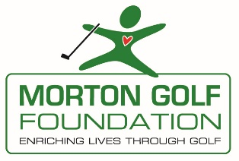
In an effort to recognize juniors that have gone through any Northern California Golf Association, the First Tee - Greater Sacramento or high school program or worked at a golf facility and assist them with their higher education needs, the Morton Golf Foundation will provide college scholarships in 2023 to be given to high school seniors in Sacramento regional schools.
Eligibility
- Must have completed the junior year of high school.
- Must enroll at a college or university of his/her choice. Community colleges & Trade schools are eligible.
- Must have outstanding personal character, sportsmanship, and leadership qualities.
- Must have participated in a JGANC, JTNC, First Tee – Greater Sacramento member or any high school golf team for at least one event, program or membership year or worked at a golf facility during your high school years.
- High school must be within a 50 mile drive of the Haggin Oaks Golf Complex.

Rules for Application
- Complete application and attach a recent photo to the application.
- Application must be accompanied with 2 letters from the principal, golf coach teacher or counselor.
- A transcript of applicant’s grades must be included.
- Answer 4 essay questions located on scholarship application.
- All applications must be received at Haggin Oaks on or before April 3rd, 2023.
- Mail to: Morton Golf Foundation, 3645 Fulton Ave., Sacramento, CA 95821 –OR-
Hand deliver to: Haggin Oaks Golf Complex, ATTN: Morton Golf Foundation, Jane Siebers

Selection Committee and Process:
The Morton Golf Foundation scholarship committee will make the selection of those members deemed most worthy of the scholarships.

Due to National College Athletic Association rules, scholarship winners will not receive cash directly. Scholarship recipients are required to submit the name, address and contact person of their college or university so that the Morton Golf Foundation can send the funds to be held at the college in the name of the winner for future use.

Please feel free to contact me with questions at jsiebers@hagginoaks.com or (916) 808-0969.

Sincerely,

Jane F. Siebers
Morton Golf Foundation
“Enriching Lives Through Golf”
EIN 26-4351450

