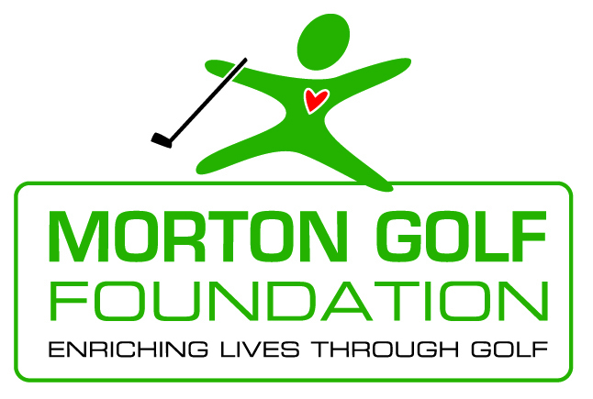

Introducing the Morton Golf Foundation

The principles of Morton Golf LLC, a golf facility management company, have been in the golf business for over 50 years. Over the last five decades, their interest in bringing the values and the recreational aspect of the game of golf to junior golfers and more recently to the disabled community and the under-served, has led them to create the Morton Golf Foundation. The Morton Golf Foundation was created for the purpose of working with other 501c3 organizations and individuals to promote better health, to provide educational scholarships, to bring the lifestyle of golf to the underprivileged and underserved and to teach life’s core values that emanate from the great game of golf. Those needs will generally be supported within the Sacramento Region.

The Morton Golf Foundation will derive revenues through grant opportunities, in-kind donations, volunteer support, legacies, special events and sponsorships from businesses, corporations and individuals.

Grant Application Procedures

Grants to other 501c3 organizations and/or to individuals must first fill out a standard application form, then be approved by the Morton Golf Foundation Board of Directors and finally provide the necessary documentation requested to account for how the funds were used. Applications will be reviewed at quarterly Board Meetings. For more information, please contact:

Morton Golf Foundation
3645 Fulton Avenue
Sacramento, California 95821
(916) 808-0969
jsiebers@hagginoaks.com

All inquiries are to be directed to Jane Siebers of the Morton Golf Foundation.

Morton Golf Foundation Grant Application

Name of Organization Applying for Grant:

Address: _______________________________________________________________

Phone: ( ) ___________________ Tax ID # ________________________________

Website Address: ________________________________________________________

Name of CEO, President or Executive Director: ________________________________

Contact Person: ____________________________ Title: _______________________

Address: _______________________________________________________________

E-Mail: _______________________________ Phone: ( ) ____________________

About your application:

Name of Program/Reason for application: _____________________________________

________________________________________________________________________

Describe: _______________________________________________________________

________________________________________________________________________

Amount Requested: $________________

Major funding sources to date: ____________________________________

_____________________________________________________________

How did you learn about our Grants Program? _________________________________

_______________________________________________________________________

Has this organization applied for a Morton Golf Foundation grant before? ___________

Purpose of Program: _____________________________________________________

_______________________________________________________________________

And/or Mission of Program: _______________________________________________

_______________________________________________________________________

Needs funds will be used for: _______________________________________________

_______________________________________________________________________

Measurable Goals: _______________________________________________________

_______________________________________________________________________

Contribution Program brings to the Community: _______________________________

_______________________________________________________________________

Target Population: _______________________________________________________

Number served: ______________________

Age Range: _________________________

Geographic Area/s Served: ___________________________________________

Location/s: ________________________________________________________

How are participants recruited? ____________________________________________

______________________________________________________________________

How is the program structured? ____________________________________________

______________________________________________________________________

Hours of Instruction? _______________________________________________

Days per week/month? ______________________________________________

Duration of Program? _______________________________________________

Levels of instruction offered? _________________________________________

How many times will each participant play a golf course during the program? ___

Explain: __________________________________________________________

Please Provide:

- An Organizational Operating Budget
- Last 2 years Organizational Balance Sheet
- Total $ Needed for Program: $_________________
- Annual Program Operating Budget
- Where will Grant $ be used:

Instruction ___________ How much? $__________________________

Equipment ___________ How much? $ _________________________

Administration ________ How much? $ _________________________

History:

Organization: _________________________________________________________

_____________________________________________________________________

_____________________________________________________________________

_____________________________________________________________________

Program History: ______________________________________________________

_____________________________________________________________________

_____________________________________________________________________

_____________________________________________________________________

Past Accomplishments: _________________________________________________

_____________________________________________________________________

_____________________________________________________________________

_____________________________________________________________________

What % of participants continue to play golf after the program ends? _____________

_____________________________________________________________________

Attachments To Include with Application:
- Letter of Determination from IRS for 501c3 status
- Detailed Operating Budget of Organization
- Itemized Program Budget
- List of Board of Directors
- For non-profit corporations only – a photocopy of you current U. S. Treasury Tax exempt status
- Please enclose a copy of last year’s program schedule/promotional materials and/or press clippings
- Please submit application to jsiebers@hagginoaks.com or mail to 3645 Fulton Ave., Sacramento, CA 95821

For Office Use Only:

Date Grant Application is received: __________________________________________

Reviewed and approved: Yes __________ No __________

Amount Granted $ _______________________________________________________

By: _________________________________ Date: __________________________

Date Check Cut: _________________________________________________________

Date to send Feedback Letter/Information: ____________________________________

Date we require Feedback Letter/Information to be returned: ______________________

